Mission Zero - Becoming a PrivaPal
UX-Flow: Sign up/creating account
Main Learning Objective: Children should have a general understanding of what the Children's Online Privacy Protection Act (COPPA) is and how it can help protect them.
How do we teach them this?
- We want to actively engage the users in-tasks as we know from research by Alotaibi (2024) game-based learning provides children with a sense of autonomy and competence in completing gamified tasks, leading to higher levels of engagement and motivation.
- We will want to break-down the process of signing-up into TASKS (with different screens). So maybe the first screen can be the introduction and state something simple such as “The journey to becoming a Priva-Pal starts with the following tasks…”
Task Breakdown: “The journey to becoming a Priva-Pal starts with the following tasks…”
Task One: Entering birth month and year
- Age-Gate Logic: Simple drop down list of months and years.
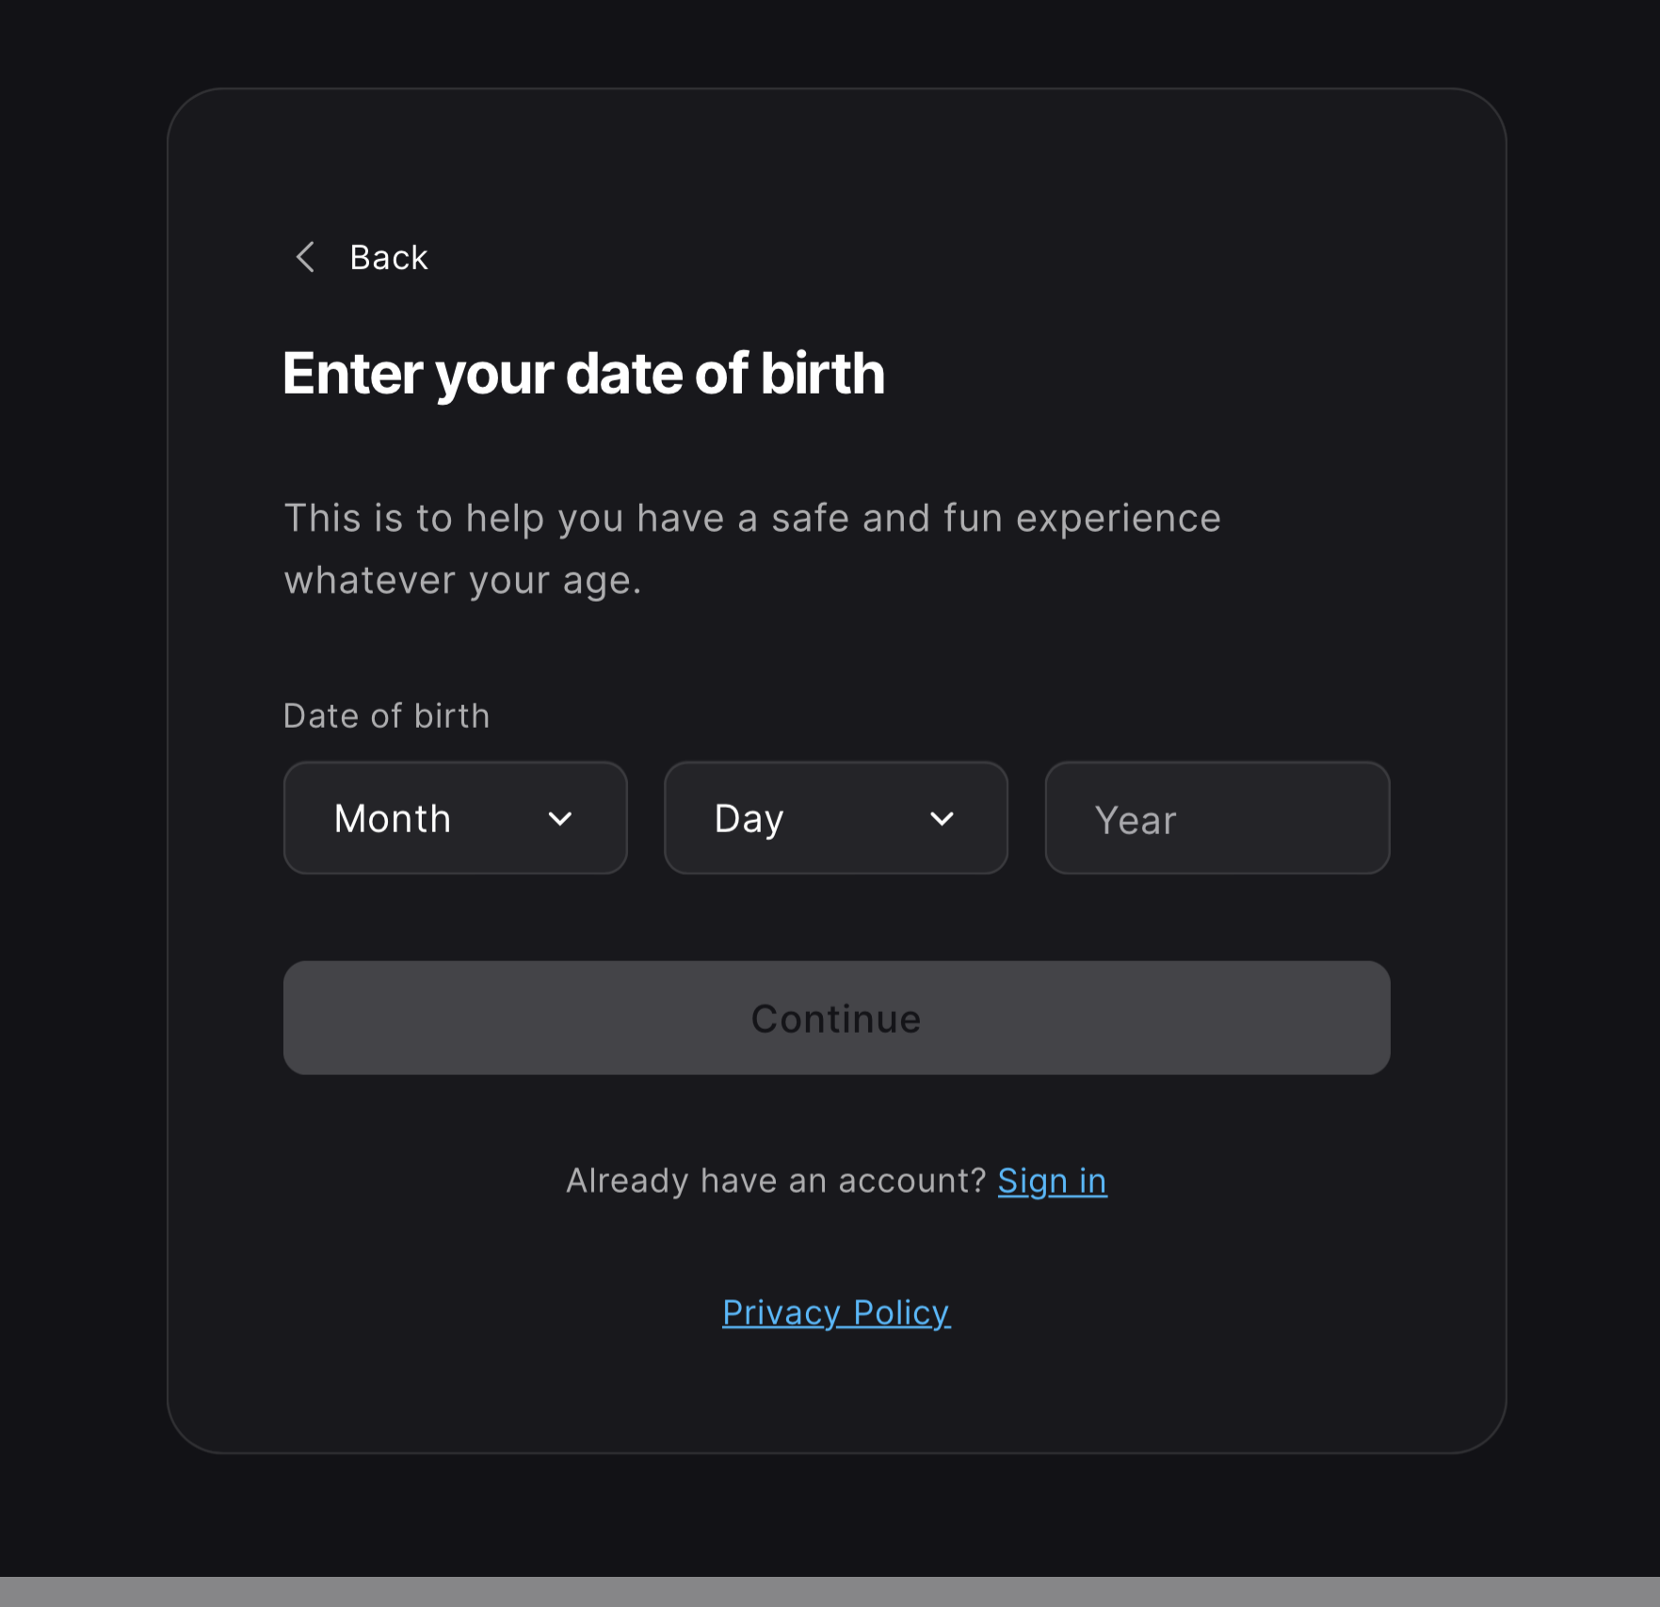
Task Two: Obtaining parent or guardian consent.
- Must explain to the user why we need this: “We see you're under 13. Before you can become a Priva-Pal, we need your parent or guardian's permission so they can become your Privacy Guard. Each Guard has the right to see, change, or delete anything we know about you.”
- Must include PRIVACY POLICY & TERMS AND CONDITIONS!!!
Task Three: Creating Agent Name (aka, username).
- A text field appears with real-time feedback.
- If the user types something that resembles a real-name, we will flag it (e.g., “Heads up! Keeping your real identity private online is your first line of defense).
- If they ace it, points awarded?
Tasks Four: Setting Users Privacy Shield
- Settings to improve game experience, will be optional and their default setting will be off.
- Privapal explains to users: “You're in control of what you share. Turning these off won't affect your game.”
- Each opinion presented as toggle to switch on/off
  - Game progress visible to friends
  - Sound and accessibility preferences
^^ Work-in-progress

POSSIBLE GAME MISSIONS!!

Mission Two: The Tracking Web
Main Learning Objective: Teach kids that apps and websites track their behavior even when they're not actively sharing anything.
Game-play Mechanics: simulation where the users browses fake websites and Privapals reveals in real-time what invisible data is being collected about them without their awareness.
Why this matters: Zuboff’s work on surveillance capitalism teaches us that data is not just a byproduct of using the internet, it’s the product itself. Companies collect behavioral data from users, including children, to create predictive profiles that are bought and sold without user knowledge nor consent. Zhao et al. found that while children could identify and form responses to obvious privacy risks like oversharing personal information, they consistently failed to recognize passive data collection. Here, we aim to make the invisible, VISIBLE.
Sources:
- Zuboff, S. (2018). The Age of Surveillance Capitalism
- Farthing, R., Koren Ošljak, K., Akuetteh, T., Camacho, K., Smith-Nunes, G., & Zhao, J. (2024). Online Privacy, Young People, and Datafication: Different Perceptions About Online Privacy Across Antigua & Barbuda, Australia, Ghana, and Slovenia.
- Zhao, J., Wang, G., Dally, C., Slovak, P., Edbrooke-Childs, J., Van Kleek, M., & Shadbolt, N. (2019). `I make up a silly name’ Understanding Children’s Perception of Privacy Risks Online. In CHI Conference on Human Factors in Computing Systems Proceedings, 1–13.

Mission Three: The Ad-Machine
Background: Builds upon mission two, showing kids the relationship between cause and effect (data tracking leads to targeted ads).
Main Learning Objectives: Teaching users that data collected about them while browsing the internet is actively used to build profiles that determine what ads, content, and products are shown to them, which is meant to influence their behavior.
Game-play Mechanics: Child is shown a recap of their fake browsing history from Mission Two (e.g., the websites they visited, how long they stayed, what they clicked, etc). Privapal will then have the user step into the role of THE AD COMPANY, Privapal will then have the user step into the role of THE AD COMPANY, being told to use what they know about this user to build their profile. For each category (e.g., interest, habits, demographics), the user will drag clues from the browsing history into the profile, piecing together who this person is purely from behavioral data. Once the profile is complete, Privapals will reveal their identity to themselves, showing that the profile they just built was about themselves.
Why this matters: Children see targeted ads all the time, being vulnerable to manipulation from large corporations (Zuboff, 2018; Raffoul et al., 2023). In mission two, users will have learned about *HOW* data is passively collected about them. However, mission three will show users *WHAT* that data is being used for… targeted ads that are chosen through predictive profiling.
Sources:
- Raffoul, A., Ward, J., Santoso, M., Kavanaugh, J., Austin, B. (2023). Social media platforms generate billions of dollars in revenue from U.S. youth: Findings from a simulated revenue model.
- Zuboff, S. (2018). The Age of Surveillance Capitalism

Mission Four: The Voice in the Room
Main Learning Objective: Teach kids that voice assistants are always listening, and that the recordings they capture are stored and sometimes shared with third parties

